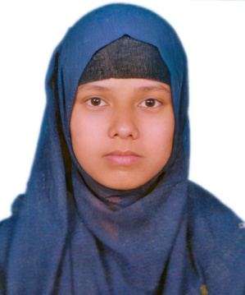***Resume Of Hosneara Khatun***

Contact No.: +8801810358863

Email : hosnearakhatun176 @gmail.com



LinkedIn : Hosneara Khatun

GitHub : Hkhosneara

# Career Objectives

To develop career in dynamic and challenging environment where hard work, strick discipline, sincerity is welcomed. I have a desire to utilize my technical skill, talent, creativity, and sincerity for the better achievement of the organization.

# Personal Skill And Qualities

* Hard Worker, Innovative and very responsible person.
* Able to work confidently under pressure in different situation to meet the deadline.
* Strongly believe in teamwork.
* Co-operative and Good communication skills.
* Strong analytical and problem solving skills.
* Organization &leadership competence with strong interpersonal relationship.

# Educational Qualification

|  |  |  |  |  |
| --- | --- | --- | --- | --- |
| **Exam Title** | **Group/ Major** | **Institute** | **Result** | **Passing year** |
| Bachelor of Science (B.Sc.) | Chemistry | Begum Rokeya University, Rangpur. | Continue |  |
| HSC | Science | DInajpur Govt. College | GPA: 5.00 out of 5.00 | 2020 |
| SSC | Science | Binod Nogor High School | GPA:5.00 out of 5.00 | 2018 |

**Training & Courses Summary**

|  |  |  |  |  |
| --- | --- | --- | --- | --- |
| **Name Course** | **Organization Name** | **Department** | **Year** | **Duration** |
| Industrial Training on Chemical  Analysis and  Quality control | Training institute For Chemical Industries (TICI), Polash,  Narsingdi, Bangladesh. (Central Training Institute of BCIC) | Analytical  Chemistry &  Environmental Science | 2024 | Four weeks  (21/09/2024 -  17/10/2024) |

# Language Proficiency

|  |  |  |  |  |
| --- | --- | --- | --- | --- |
| **Language** | **Reading** | **Writing** | **Listening** | **Speaking** |
| **Bengali** | Excellent | Excellent | Excellent | Excellent |
| **English** | Excellent | Good | Good | Good |

# Computer Skills

* Microsoft Office: MS Word, MS Excel, MS Power Point.
* Internet Browsing.
* Basic knowledge of computer hardware and software maintenance and E-mail service.
* Google Classroom
* Chem Draw

# Personal Information

|  |  |  |
| --- | --- | --- |
| Father’s Name | : Amdadul Haque | |
| Mother’s Name | : Raseda Begum | |
| Date of Birth | : 25-06-2002 | |
| Gender | : Female | |
| Marital Status | : Unmarried | |
| Nationality | : Bangladeshi | |
| Religion | : Islam | |
| Permanent Address | : Kolomdarpur, Binod Nogor,  Nawabgonj, Dinajpur | |
| Current Location | : Park More , Rangpur Sadar. | |
| Blood Group | : B (+ve) |
| Reference |  |

|  |  |
| --- | --- |
| **Mostafa KaiyumSharafat**  Lecturer  Department of Chemistry  Begum Rokeya University, Rangpur. Phone: +8801734785596  Email: mksharafat10@gmail.com | **Dr. Md. Abdul Latif**  Associate Professor  Department of Chemistry  Begum Rokeya University, Rangpur.  Phone: +8801798100131  Email: latif503@yahoo.com |

# Declaration of Authenticity

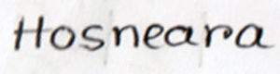I hereby solemnly declare that the information which I have provided is true according to my knowledge and will be able to submit all needful documents in support of the aforementioned information if required.

Hosneara Khatun